**UNITED SOCIALIST REPUBLICS**

**PENNSYLVANIA FEDERATION**

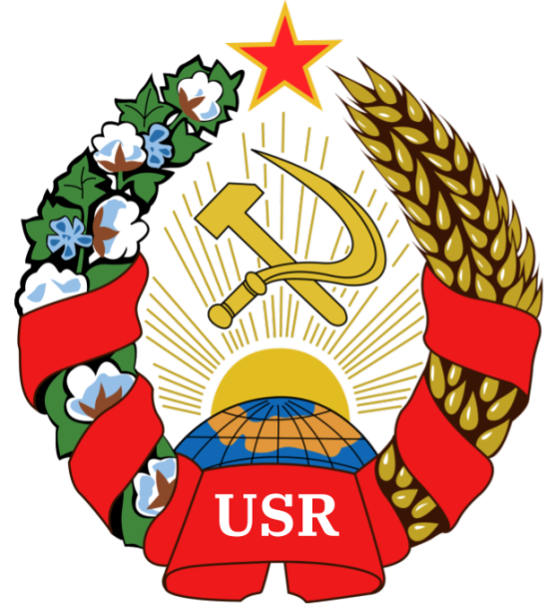 

**Treaty of Friendship, Allyship and Cooperation between the Pennsylvania Federation and the United Socialist Republics**

**Author:** Comrade GENERAL SECRETARY TIZIAN ARUNA and PRESIDENT RICHRACC

**Sponsored by:** The UNITED SOCIALIST REPUBLICS and it’s PEOPLE’S COMMISSARIAT OF EXTERNAL AFFAIRS, along with the PENNSYLVANIA FEDERATION’S OFFICE OF THE PRESIDENT

Hereby releases this document to the public.

* Article 1: The Parties shall establish diplomatic relations and maintain an embassy in each other's capital.
* Sub-Article 1.1: The Parties shall exchange ambassadors and other diplomatic personnel, in accordance with established diplomatic protocols.
* Sub-Article 1.2: The Parties shall facilitate the movement of diplomatic personnel between their respective capitals, and shall provide all necessary assistance for the performance of their duties.
* Article 2: The Parties shall not engage in any act of aggression, hostility, or interference in the internal affairs of the other Party.
* Sub-Article 2.1: The Parties shall refrain from the use of force or the threat of force against each other, and shall respect each other's sovereignty and territorial integrity.
* Sub-Article 2.2: The Parties shall refrain from providing support or assistance to any non-state actors or groups that engage in acts of aggression or terrorism against the other Party.
* Article 3: The Parties shall cooperate in the field of economy, trade, culture, and education. They will encourage and facilitate the exchange of goods, services, and information, as well as the exchange of students, scholars, and artists.
* Sub-Article 3.1: The Parties shall encourage and facilitate the exchange of goods and services, through the establishment of trade agreements, the removal of tariffs and other trade barriers, and the promotion of investment.
* Sub-Article 3.2: The Parties shall encourage and facilitate the exchange of information and knowledge, through the establishment of cultural and educational exchange programs, the promotion of scientific research, and the protection of intellectual property rights.
* Article 4: The Parties shall cooperate in the field of science and technology, with a focus on research and development in areas of mutual interest such as renewable energy, sustainable development, and healthcare.
* Sub-Article 4.1: The Parties shall collaborate on research and development in areas of mutual interest, such as renewable energy, sustainable development, and healthcare.
* Sub-Article 4.2: The Parties shall exchange scientists and technical experts, and shall provide all necessary support for the conduct of joint research and development projects.
* Article 5: The Parties shall cooperate in the field of defense, with a focus on disaster relief, peacekeeping, and counter-terrorism efforts. They shall consult each other in the event of a threat to regional peace and stability.
* Sub-Article 5.1: The Parties shall establish a mechanism for regular consultation on defense and security matters, and shall exchange information on military activities, capabilities, and plans.
* Sub-Article 5.2: The Parties shall cooperate on disaster relief and humanitarian assistance, and shall provide support to each other in the event of natural disasters or other emergencies.
* Article 6: The Parties shall respect each other's sovereignty and territorial integrity, and shall settle any disputes that may arise between them through peaceful means, such as diplomatic negotiation or mediation.
* Sub-Article 6.1: The Parties shall resolve any disputes that may arise between them through peaceful means, such as diplomatic negotiation or mediation, and shall refrain from the use of force or other forms of coercion.
* Sub-Article 6.2: The Parties shall respect each other's sovereignty and territorial integrity, and shall refrain from any actions that might be interpreted as a violation of these principles.

**SIGNED**

**General Secretary Tizian Aruna**



**President RichRacc**

**RichRacc**